**2024 AAU Junior Olympic Games, Greensboro, NC**

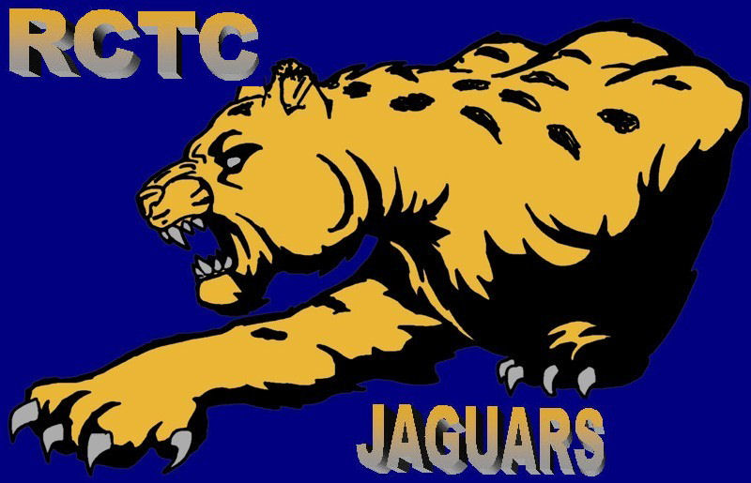

**Day 1 Monday** We started the morning with the jumps. In the long jump we have Reese Scivally with a leap of 16-5(55th), Devaun Butler jumped 21-8(35th) follow up with also Ryan Moore 17-6(22nd)PR we finished with Xarya Udoumana now 2X ALL-AMERICAN with a jump of 18-7.75(4th). In the running events we had the hurdles, 200mH with Reese Scivally 28.32(21st) then onto the 800m preliminaries with Elijah Johnson 2:02.21(15th)PR, Brea Vann 2:24.65(20th)PR, Ava Creger 2:32.83(49th), Kyla Joy 2:20.13(PR) and Camryn Merryman 2:15.78 both qualified for the finals on Wednesday, ending the day we had the 200m Autumn Carter 27.26(60th) and Jude Fayissa 23.01(52nd). **Congratulations** to all those that competed today.

**Day 2 Tuesday** 1st event of the day was 1500m Barrett Tablak 4:47.32(31st), Ethan Reyes 4:13.05(2nd )PR 9xALL-AMERICAN , Ainsley Sparkman 5:20.04(36th), Ava Creger 5:28.63(26th), and Jayden Batts 4:33.90(61th), then we moved onto the sprints with the 100m Zavier Smith 14.42(76th), Arianna Isbell 12.56(35th) & Autumn Carter 13.25(61st). In the field events we started with the long Kai Owusu, 14-3.75(3rd) now 2xALL-AMERICAN, then onto the throws we have Sania McGhee threw 102.10(37th) in the discus, and the shot put Justin Williams 37-6.5(34th)PR and Kensley Reams 26-1(3rd) now 3x ALL-AMERICAN. We ended the day with the triple jump Amira Maynard with a leap of 33'2(51st). Congratulations again to all our athletes.

**Day 3 Wednesday**

We had the finals of the 800m and it was electrifying. Camryn Merryman 2:12.33(2nd)PR is now 5x ALL-AMERICAN and Kyla Joy 2:16.36(8th)PR now 2x ALL-AMERICAN, then we had the hurdle races Reese Scivally 100mh 14.41(17th)PR. Next we moved to the field events and we had Sania McGhee 34'10.5(24th)PR, and save the best for last. Ryan Moore is the 2024 AAU Junior Olympic champion in the triple Jump 39'5(1st)PR ALL-AMERICAN. Congratulations to all our athletes that competed today

**Day 4 Thursday**  We started with distance races, the 1500m Lillian Wilson 6:59.05(54th) and Callum Tablak 5:26.83(31st)PR, then onto field events, long jump Arianna Isbell 17'9.5(9th) and ended the day with the 4x400 Relays 15-16 girls (Jurnee Rutherford, Kirsten Cochran, Arianna Isbell, Kiersten Flowers) 4:06.16(21st) 17-18 men (Devaun Butler, Ray'Shun Perrin, Reynaldo Hill, Lamont McCullough) 3:27.29(37th) and the women 17-18 (Kyleigh Turks, Kyla Joy, Camryn Merryman, Emoni Owens) 3:50.56(6th) qualified for the finals on Saturday. Congratulations to all those that competed today

**Day 5 Friday**  Day 5 Friday

We started with the relays 4x800 17-18W (Brea Vann, Ava Creger, Kyla Joy, Camryn Merryman) 9:35.25(1st) ALL-AMERICAN are the 2024 AAU National Champion, then we move to the 4x100 15-16G (Jurnee Rutherford, Kirsten Cochran, Kiersten Flowers, Arianna Isbell) 49.14(34th), 15-16B (Jaylin Maclin, Easton Baker, Trevor Spivey, Jude Fayissa 44.62(35th), and 17-18M Monte Holliday, Declan Cager, Gary Willis, Devaun Butler) 43.06(39th) next we moved to the 400m Kiersten Flowers 1:04.12 & Elijah Johnson 50.27(23rd), due to inclement weather Camryn Merryman and Kyla Joy will run their 400m tomorrow time finals. In the field events we had Michael Isbell in the long jump 12-10.75(44th) and finished the day with the high jump Reese Scivally 5'8.75(7th) is now 2x ALL-AMERICAN. Congratulations to all our athletes

.

**Day 6 Sat** We started the morning with the 3000m and Ethan Reyes 9:31.02(2nd)PR now 10x ALL-AMERICAN, then onto the 400m finals [Kyla Joy](https://www.facebook.com/groups/120250145766/user/100055211734080/?__cft__%5b0%5d=AZV7ElP2XRbs9x-YEUp2TAlYByFdNTC8pDpbay_ARLx4wLZGe3ddnT8nzvPl1Q5o42ytLRPa2NtKbJFBwiakDDCt73Nd51xlfmXSOkSE1Ek2flZetEeoNUuho3ljE6VVKu7T1gQ3iECtjefkBKGQtKqvn7UO7MYEU4kM7F2J5OiaiJNDshP2d2FAlIYsRrwaBzUqQbw6-fhdgFCJb0_GkuKwJIZ04C90Nmg4GckxNk2upg&__tn__=-%5dK-R) 58.76(39th) and Camryn Merryman 55.68(6th)PR 6x ALL-AMERICAN and the field events we have Inioluwa Ojemuyiwa in the Turbo Javelin 57'9(17th)PR and Kensley Reams 43'4.25(41st) and we finished it with the 4x400 relay 17-18W (Kyleigh Turks, Kyla Joy, Camryn Merryman, Emoni Owens) 3:51.91(7th) ALL-AMERICAN. Congratulations to all our athletes